**Project Planning Phase**

**Project Planning Template (Product Backlog, Sprint Planning, Stories, Story points)**

|  |  |
| --- | --- |
| Date | 18 October 2022 |
| Team ID | PNT2022TMID30303 |
| Project Name | Emerging Methods for Early Detection of Forest Fires |
| Maximum Marks | 8 Marks |

**Product Backlog, Sprint Schedule, and Estimation (4 Marks)**

| **Sprint** | **Functional Requirement (Epic)** | **User Story Number** | **User Story / Task** | **Story Points** | **Priority** | **Team Members** |
| --- | --- | --- | --- | --- | --- | --- |
| Sprint-1 | Data Collection and Preprocessing | USN-1 | Download data and filter | 1 | High | Santhosh S |
| Sprint-1 | USN-2 | Taking pre-processing measures for better data | 3 | High | Revathy V |
| Sprint-1 | USN-3 | Image data generator | 2 | Medium | Shyam V |
| Sprint-1 | USN-4 | Generating train and test data | 2 | Medium | Dhinakaran K |
| Sprint-2 | Model Building and Integrating Twilio | USN-5 | Model building measures for building better model | 2 | High | Revathy V |
| Sprint-2 | USN-6 | Model building initializing and adding layers | 3 | High | Dhinakaran K |
| Sprint-2 | USN-7 | Train model with data | 3 | High | Santhosh S |
| Sprint-2 | USN-8 | Integrating with Twilio | 2 | High | Shyam V |
| Sprint-3 | Deploying with OpenCV Live Cam | USN-9 | Saving model and loading the OpenCV model | 1 | Medium | Dhinakaran K |
| Sprint-3 | USN-10 | Set OpenCV for live cam | 2 | High | Shyam V |
| Sprint-3 | USN-11 | Connecting front-end and back-end | 3 | High | Revathy V |
| Sprint-3 | USN-12 | Deploying application using IBM Cloud | 4 | High | Santhosh S |
| Sprint-4 | Testing and Reinforcement | USN-13 | Testing the whole model | 3 | High | Shyam V |
| Sprint-4 | USN-14 | Alteration and modifications | 2 | Medium | Santhosh S |
| Sprint-4 | USN-15 | Integrating Flask | 2 | Low | Revathy V |
| Sprint-4 | USN-16 | Final Testing | 3 | High | Dhinakaran K |

**Project Tracker, Velocity & Burndown Chart: (4 Marks)**

| **Sprint** | **Total Story Points** | **Duration** | **Sprint Start Date** | **Sprint End Date (Planned)** | **Story Points Completed (as on Planned End Date)** | **Sprint Release Date (Actual)** |
| --- | --- | --- | --- | --- | --- | --- |
| Sprint-1 | 8 | 6 Days | 24 Oct 2022 | 29 Oct 2022 |  |  |
| Sprint-2 | 10 | 4 Days | 30 Oct 2022 | 02 Nov 2022 |  |  |
| Sprint-3 | 10 | 5 Days | 03 Nov 2022 | 07 Nov 2022 |  |  |
| Sprint-4 | 10 | 5 Days | 08 Nov 2022 | 12 Nov 2022 |  |  |

**Velocity:**

Average Velocity = 10/4 = 2.5

**Burndown Chart:**

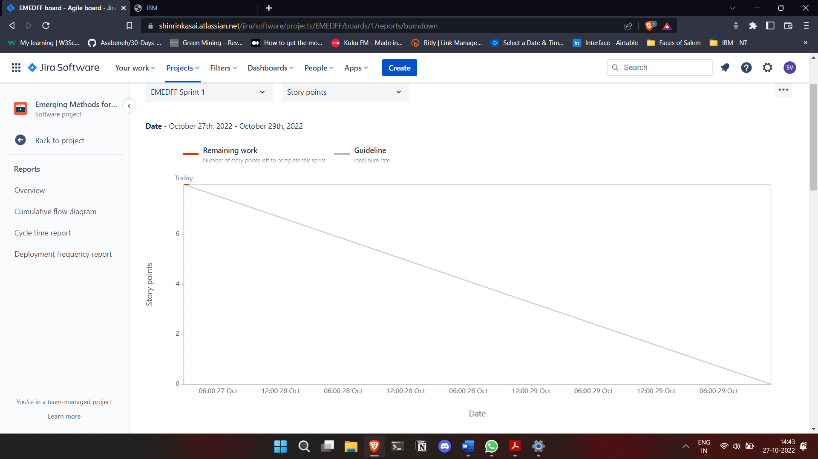

**Roadmap:**

